# Instructions - Exercise 2.3 – Data Binding

The basic layout is:

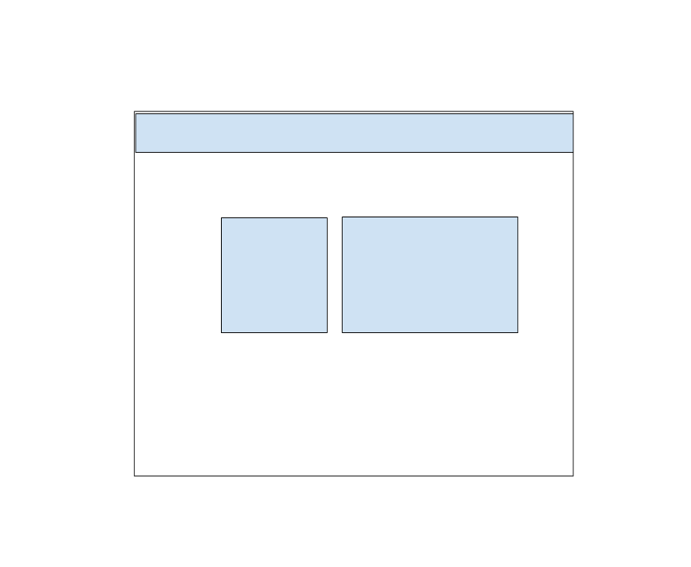

profile-app, part 2

**Instructions**

* Generate a new Angular application and call it enhanced-profile-app
  + Enter “n” for routing
* Recreate the profile-app from Assignment 1.5
* app.component.ts
  + Define a **isLoggedIn** variable with a Boolean data type and assign it a default value of true
  + Remove the title variable and add a new one named assignment of type string
  + Give the assignment a value of “Exercise 2.3 - Data Binding”
* app.component.html
  + Add an h2 element above the profile components and give it the value of our assignment variable
  + Add an ng-template directive and name it showError
  + Inside the ng-template add a Bootstrap row div and a 12 column div.  Inside the 12-column div add a single message saying, “You are not authorized to view this content” and give the div a class of alert-error
  + Add an *ngIf to the row div and check if the isLoggedin value is true.  In the else clause call the “showError” ng-template
    - If you are not sure how to create if...else statements using ng directives, search the Internet for “If else statements in Angular”
* Run and test the application by changing the isLoggedIn value in the app.component.ts from true to false
* my-details.component.ts file
  + Create a TypeScript class and name it Person
  + Person
    - fullName: string
    - favoriteFood: string
    - favoriteColor: string
    - keywords: [“#TypeScript”, “#2020”, “#CodingWIthAngular”, “#ngOmaha”]
    - constructor(fullName: string, favoriteFood: string, favoriteColor: string)
      * Assign the passed-in parameters to the class fields
  + Define a new variable called myProfile and give it a data type of Person
  + In the components constructor create a new instance of the Person class and pass-in your actual full name, favorite color, and favorite food
* my-details.component.html
  + Replace the hard-coded values for full name, favorite food, and favorite color with the values from the myProfile variable
    - {{ myProfile.fullName }}
  + Under the last list-group-item add a new list-group-item for keywords.  Inside the HTML list-group-item add an HTML span tag and *ngFor loop.  Iterate over the myProfile.keywords array and output the results
    - *ngFor=”let word of myProfile.keywords”> {{word}}
* Run and test the application